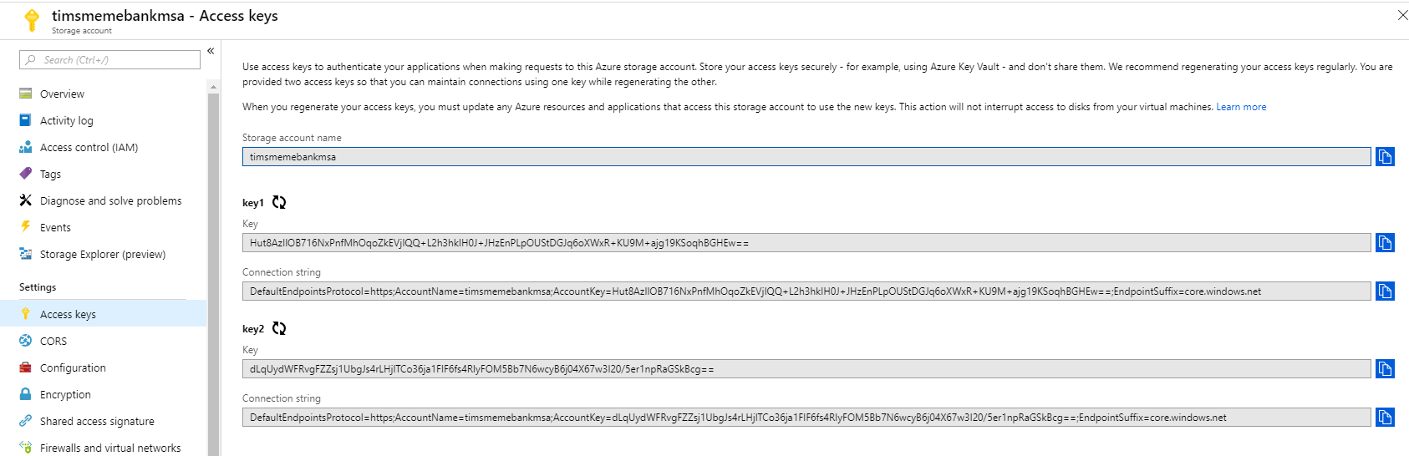

Storage account name: timsmemebankmsa

Key1: Hut8AzIlOB716NxPnfMhOqoZkEVjIQQ+L2h3hkIH0J+JHzEnPLpOUStDGJq6oXWxR+KU9M+ajg19KSoqhBGHEw==

Connection string: DefaultEndpointsProtocol=https;AccountName=timsmemebankmsa;AccountKey=Hut8AzIlOB716NxPnfMhOqoZkEVjIQQ+L2h3hkIH0J+JHzEnPLpOUStDGJq6oXWxR+KU9M+ajg19KSoqhBGHEw==;EndpointSuffix=core.windows.net

Key2: dLqUydWFRvgFZZsj1UbgJs4rLHjlTCo36ja1FIF6fs4RIyFOM5Bb7N6wcyB6j04X67w3I20/5er1npRaGSkBcg==

Connection String: DefaultEndpointsProtocol=https;AccountName=timsmemebankmsa;AccountKey=dLqUydWFRvgFZZsj1UbgJs4rLHjlTCo36ja1FIF6fs4RIyFOM5Bb7N6wcyB6j04X67w3I20/5er1npRaGSkBcg==;EndpointSuffix=core.windows.net